**Milestone 2**

**Team Member**

Sajib - 180028

Amar - 180036

Abdul - 180030

Bibek - 180010

1. **Design the architecture of the project.**

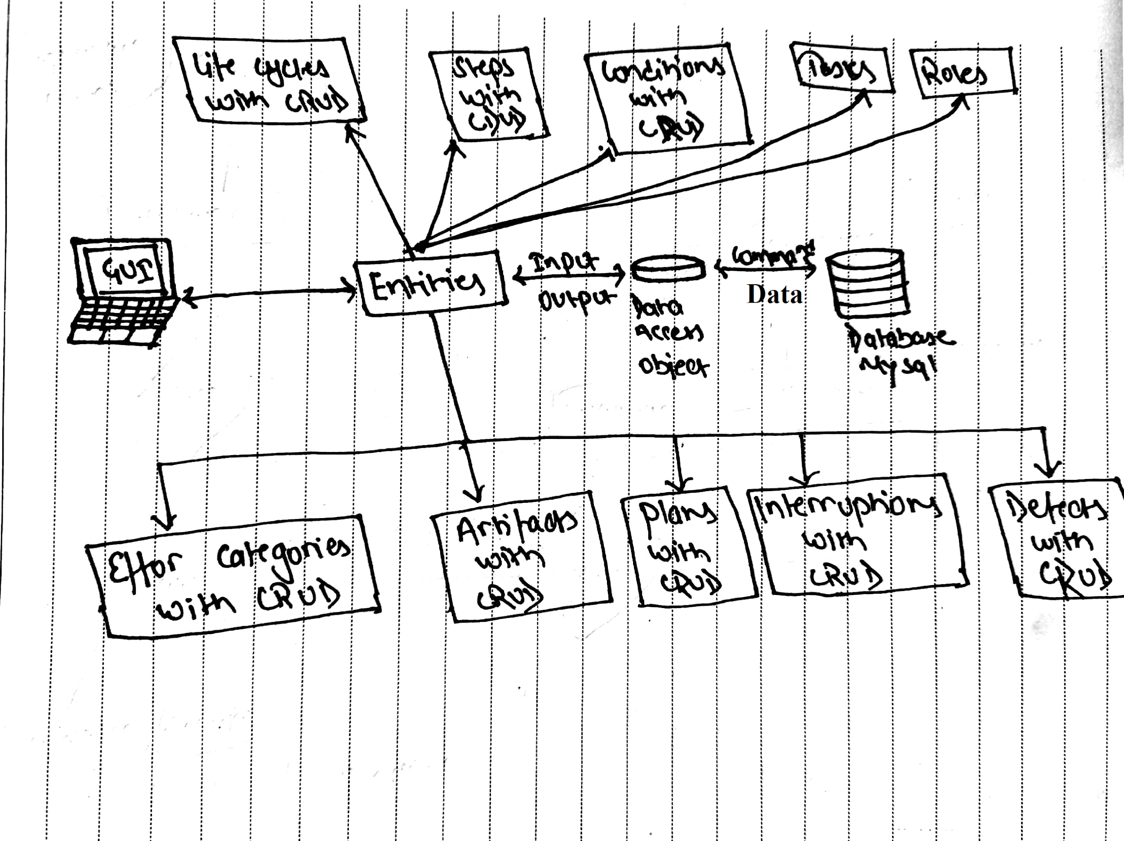

1. **Create a database and provide the snapshot for the same.**



1. **Create all necessary tables with appropriate mapping constraints(i.e. Primary Key, Foreign Key, Unique key, etc.) for the project and provide the snapshot for each.**

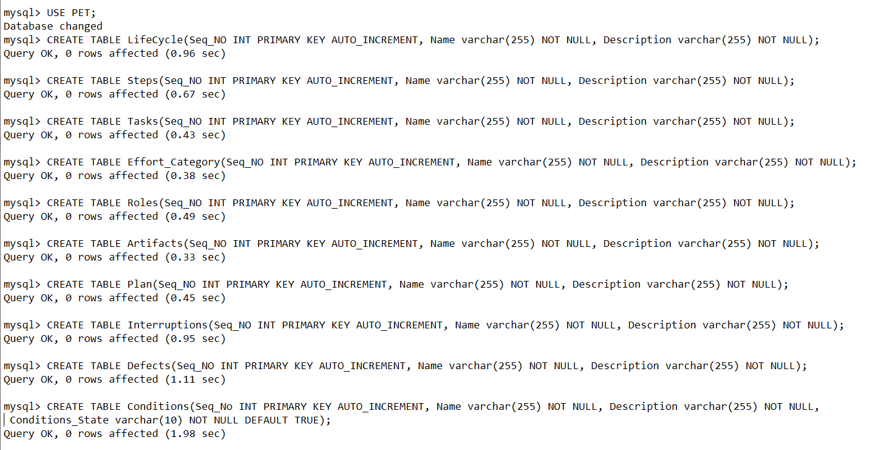

1. **Describe the structure for each table and provide the snapshot and txt file for the same.**

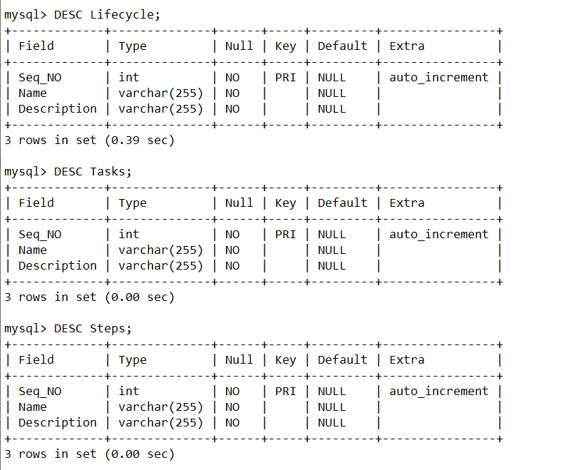

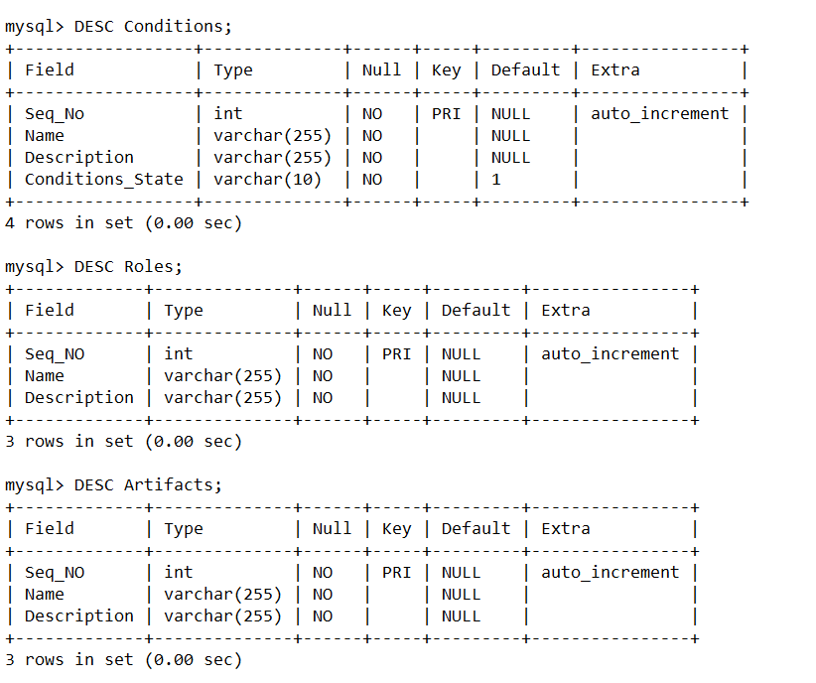

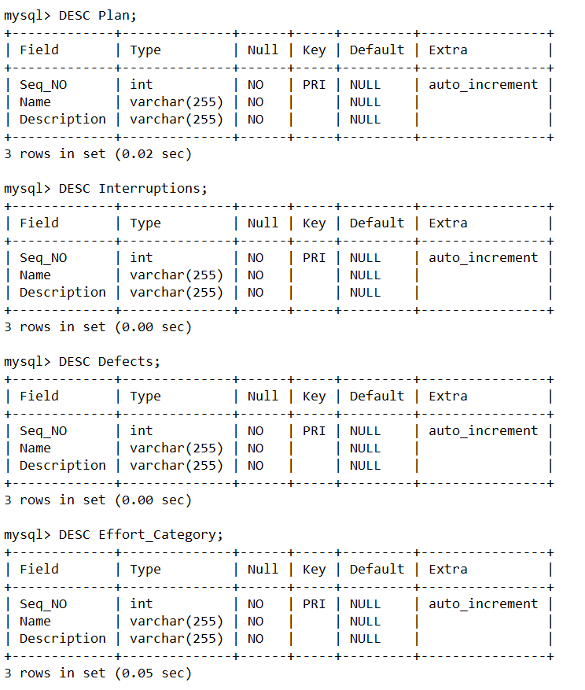

1. **Provide a brief description of each module in the project.**

Here is the description of each module in the project:

1. **Life Cycle**

This tab contains info about the Life Cycles. It has an option to add name and description and they are stored in a table. We can perform edit, save, and add operations in the tab. Along with these, this tab has the following

* TextField is for the name of the life cycle
* Description text field
* Several buttons including creating, save, edit, import, download, clear the names and definition above, upload, and remove.
* We can save the name of the life cycle using the save button.

1. **Steps**

This tab is about the steps in the life cycle. It contains step names and descriptions. We can edit, save, add, move, and delete the steps name and description.

1. **Conditions**

This tab is for the conditions. It has a table which stores the conditions. The condition contains the name, description, and state of it.

The tab has the following:

* A text area for the long description
* Text field for cycle name
* Buttons including (CRUD, add up, add down, add bottom, clear button)

1. **Tasks**

This tab is about the tasks which were mentioned in the previous tab i.e. Step. There is a table for the added tasks. The task contains names and descriptions. There are two more items that are artifacts used and artifacts produced in the task.

1. **Roles**

This tab contains details about the roles. It has the role name and description and is stored in the table. There is also an option to edit, add, and save the role. It also has a text field and a text area to store the name and description of the role. It has 9 keys, editing, saving, adding, adding down, adding down, clearing the name and description above, moving up, moving Down, and deleting.

1. **Effort Categories**

This tab contains details about the efforts. It contains effort category name and description and is stored in the table with edit, add and save options. It also contains artifact options for effort categories. Along with these, the tab has the following:

* Two combo boxes to add artifacts and storing category
* Table to store data of effort, artifact.
* A text area for the long description
* Text field for cycle name
* Buttons including (CRUD, add up, add down, add bottom, clear button)

1. **Artifacts**

It contains details about the artifacts. It has a name and description field and is stored in a table. We can edit, add, and save the artifacts. The tab has a text field and text area to store the name of the artifacts. It has 9 keys, editing, saving, adding, adding down, adding down, clearing the name and description above, moving up, moving Down, and deleting.

1. **Plans**

This tab is about the plans. It has a name and description and is stored in a table. We can edit, add, and save the plans and also clear it. The tab has a text field to enter the name of the artifact and one text area to enter descriptions.

1. **Interruptions**

This tab is about the interruptions. It has a name and description and is stored in a table. We can edit, add, and save the plans and also clear the interruptions. The tab has one test field for artifact name and one text area. It also has a table to store the interruption number.

1. **Defects**

This tab is about the Defects. It has a name and description and is stored in a table. We can edit, add, and save the plans and also clear the Defects. The tab has 9 different buttons including Edit, Save, add up, add down, add bottom, Clear the above name, and description, Move Up, Move Down and delete.